Directions From Manchester Airport to Scott & Kim’s

•Leave the Airport and turn right onto Brown Ave
(This is the first light that you will come to)
•Follow Brown Ave to route 293W (second entrance) Turn Left.
•293 W will turn into route 101W.
•Follow 101W to the first light and turn Left (this will still be route 101W).
•Follow 101W through Amherst and Milford, approx. 19 Miles.
•Rt 101 dead ends on the Westside of Milford. At the second light, turn Left onto still 101.
(State Police Post, Market Basket, and Granite Bank will be on your left, Suburban Propane on your Right).
• Turn Right at the next light (this will take you into Wilton)
• Follow this road Rt 31North to the center of Lyndeborough. (There you will see the Village store)
• From the store go 1.7 miles and turn Left on Old Temple Road.
• Follow Old Temple road until there is a fork in the road. Stay Left
• Our drive way is the first on the left after the fork. (It is a paved driveway)

Any problems locating us, please call 603-673-6600 Dial 0 or Home 603-654-6665

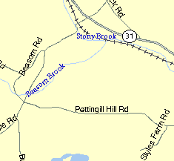
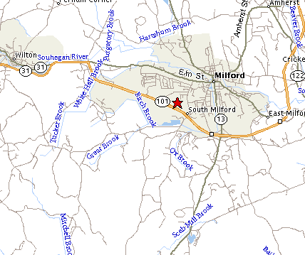
Scott & Kim

